Truss Design FDR

Sandal Squad

Avani Sheth, Alex Necakov, Willie Swift

Section A2 Professor Farny

Table of Contents:

Introduction ------------------------------------------------------------------------------------------ 3

Procedure -------------------------------------------------------------------------------------------- 3

Analysis ---------------------------------------------------------------------------------------------- 4

Data --------------------------------------------------------------------------------------------------- 4

Results ------------------------------------------------------------------------------------------------ 6

Discussion ------------------------------------------------------------------------------------------- 7

Appendix ----------------------------------------------------------------------------------------------7

1. Introduction

When designing a final truss, the main priority was to increase the maximum load by distributing the applied force as evenly as possible within the constraints. Although the preliminary design could support the minimum weight required, the team concurred that maximizing the failure load of the truss will only improve its performance, as well as minimizing the uncertainty of its calculated max load. Additionally, it was agreed that many of the same elements of a stronger truss (i.e. shorter members and increased load distribution), should also lead to a more cost efficient design. The approach for achieving this goal was to begin with the primary preliminary truss, identify which members were not being used efficiently, and, by adjusting member lengths and their respective positions within the constraints, develop an arrangement that more effectively utilizes each member. Unlike the preliminary design however, where the main motivation was to create a truss that solely fit the given specifications, the group was able to use the analysis program previously made to immediately check whether each adjustment would benefit the design or not, allowing much more precise and effective adjustments to better the design.

1. Procedure:
2. Improve existing truss design under the same specifications as outlined in the Preliminary Design Report.
3. Apply data from designed truss to analysis program to determine force analysis for each member in truss.
4. Based off of force analysis determine which member will fail first.
5. Utilize analysis program to determine maximum weight the truss can hold.
6. Utilize the correction factor equation to find the new buckling loads and maximum load for the truss to account for actual straw length versus the theoretical load.
7. Calculate virtual cost of truss using cost equation
8. Calculate load to cost ratio (max load:cost)
9. Apply uncertainty analysis to calculations using the given fit uncertainty from the class’ max compression force graph.
10. Analysis

Except for calculating the actual values of our truss from the theoretical values, the same computational analysis was utilized for the final truss design as in the Preliminary Design Report. We utilized equation 4.2 from the project manual: Factual = (ljj /lactual)α *Ftheoretical to calculate our actual failure load for the truss. To calculate uncertainty in each individual member we divided 1.45N (the uncertainty in the straw compression testing) by the buckling strength of the critical member. To calculate uncertainty in our failure load, we multiplied the buckling uncertainty for the critical member by the theoretical failure load to get the range of uncertainty. This equation applies the uncertainty in buckling strength of the critical member to the entire truss to find the overall uncertainty in the failure load.

1. Data

Final Truss Design:

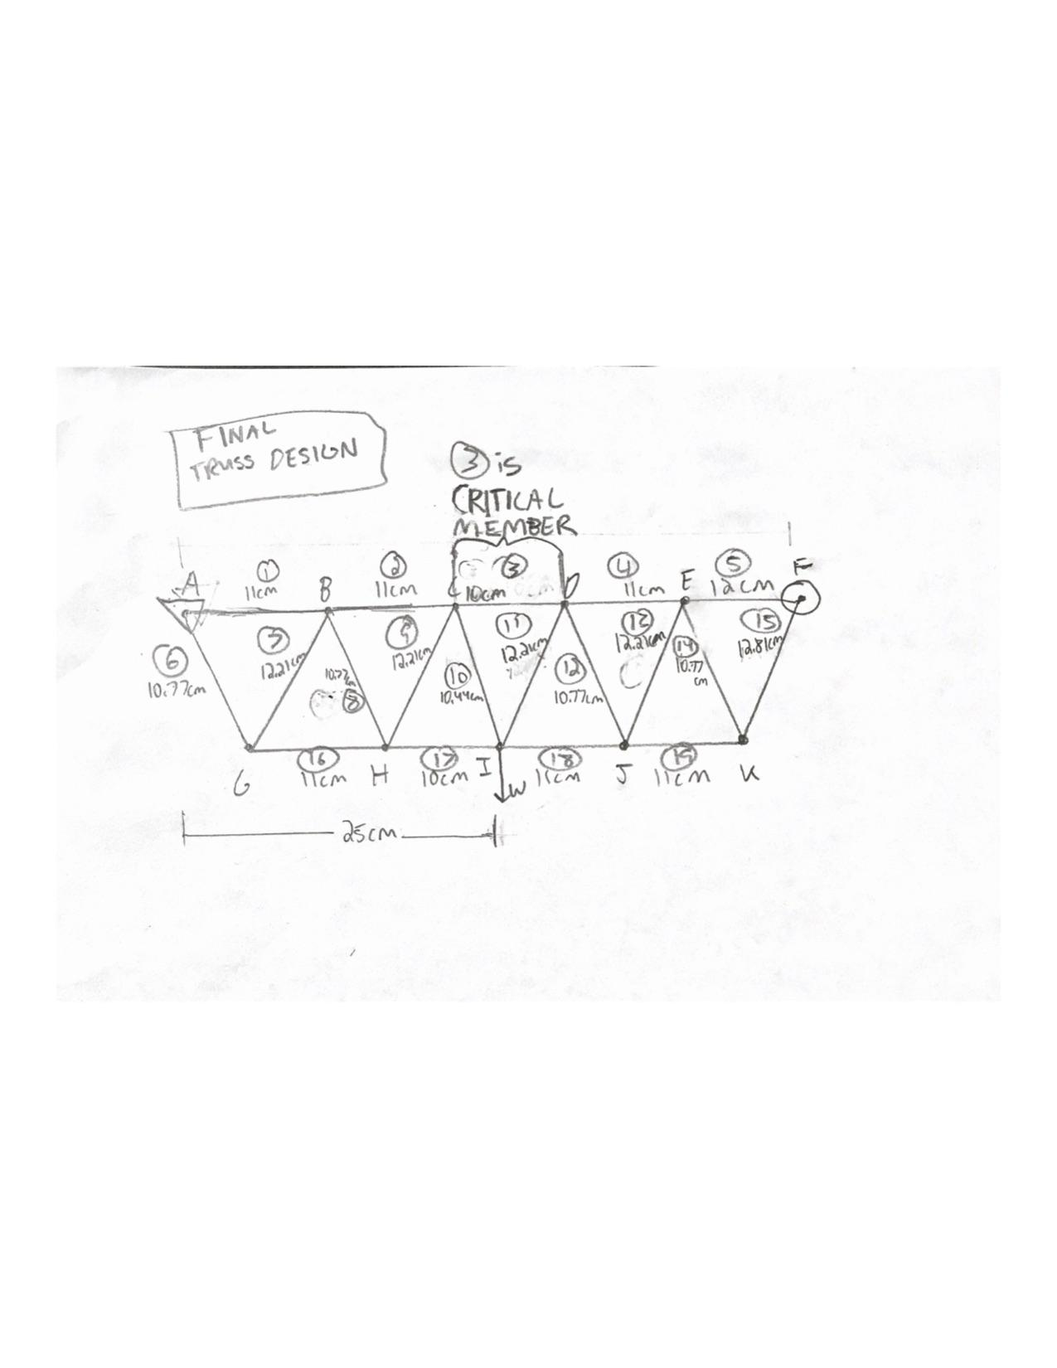

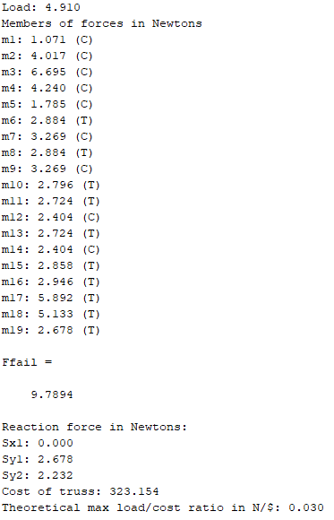

| Member # | Length (cm) | Tension/ Compression | Buckling Strength (N) | Theoretical Force at max load (N) | Actual straw length (cm) | Max supported load with actual straw length (N) | Actual Force at max load (N) |
| --- | --- | --- | --- | --- | --- | --- | --- |
| 1 | 11.0 | C | 11.0±1.45 | 2.14 | 10.5 | 12.1±1.45 | 2.35 |
| 2 | 11.0 | C | 11.0±1.45 | 8.01 | 10.5 | 12.1±1.45 | 8.79 |
| 3 | 10.0 | C | 13.3±1.45 | 13.3 | 9.5 | 14.8±1.45 | 14.7 |
| 4 | 11.0 | C | 11.0±1.45 | 8.45 | 10.5 | 12.1±1.45 | 9.27 |
| 5 | 12.0 | C | 9.27±1.45 | 3.56 | 11.5 | 10.1±1.45 | 3.88 |
| 6 | 10.77 | T |  | 5.75 | 10.27 | 12.7±1.45 |  |
| 7 | 12.2 | C | 8.96±1.45 | 6.52 | 11.7 | 9.75±1.45 | 7.09 |
| 8 | 10.77 | T |  | 5.75 | 10.27 | 12.7±1.45 |  |
| 9 | 12.2 | C | 8.96±1.45 | 6.52 | 11.7 | 9.75±1.45 | 7.09 |
| 10 | 10.44 | T |  | 5.58 | 9.94 | 13.5±1.45 |  |
| 11 | 12.2 | T |  | 5.43 | 11.7 | 9.75±1.45 |  |
| 12 | 10.77 | C | 11.5±1.45 | 4.79 | 10.27 | 12.7±1.45 | 5.27 |
| 13 | 12.2 | T |  | 5.43 | 11.7 | 9.75±1.45 |  |
| 14 | 10.77 | C | 11.5±1.45 | 4.79 | 10.27 | 12.7±1.45 | 5.27 |
| 15 | 12.8 | T |  | 5.70 | 12.3 | 8.82±1.45 |  |
| 16 | 11.0 | T |  | 5.87 | 10.5 | 12.1±1.45 |  |
| 17 | 10.0 | T |  | 11.75 | 9.5 | 14.8±1.45 |  |
| 18 | 11.0 | T |  | 10.2 | 10.5 | 12.1±1.45 |  |
| 19 | 11.0 | T |  | 5.34 | 10.5 | 12.1±1.45 |  |

1. Results

Internal force, length, buckling load, and uncertainty for all members can be found in the tables above.

For our final truss design, the critical member was still CD, aka member 3. The member is on the shorter range of available straw lengths at 11cm joint to joint, or 10.5cm actual length. The critical member has a theoretical buckling strength of 13.3N ± 1.45N and an actual buckling strength of 14.8N ± 1.45N. The range of buckling strengths came from the uncertainty of the fit of the straw strength from the straw testing lab. With this buckling strength range in mind, we came to the conclusion that the maximum theoretical load of this truss would be 9.79N +- 1.06N.

This is an improvement over the original version of this truss which had a theoretical max load of 8.09N ± 1.06N. We found the actual maximum load by applying the correction factor of (ljj/lactual)^2 to the theoretical load. The actual maximum load is 10.2N ± 1.06N. For this truss, our cost is $323, which is within the constraints of the project ($350) and $2 less than our initial truss design. Finally, our max load to cost ratio is .03N/$ which is higher than our initial load to cost ratio of .025N/$.

1. Discussion

Initially, it seemed that increasing the performance of the truss would require a radical redesign. After much deliberation, however, the team discovered that seemingly minute adjustments to the preliminary design resulted in significant improvements to the performance of the truss. With the idea of creating more symmetry around the applied load, the team systematically adjusted the length and position of appropriate members surrounding the load before checking the resulting data in the analysis program. This process was successful, and the final product was able to increase the maximum load of the truss by almost 25%.

To create a model as close to the theoretical design as possible, a paper cutter will be used cut the straws precisely. Additionally, each straw will be pinned with the pinning jigs provided, and a protractor will be utilized at each joint to recreate the same angles between members as designed. Each joint will be labeled with sharpie, and will have the correct angles drawn on them as well for easier construction.

We did not decide to adjust the load.

1. Appendix

Meeting minutes of the Hartford Roof Collapse discussion:

To discuss the Hartford Roof Collapse case, our group consisting of Avani Sheth, Alex Necakov, and Willie Swift, met on Thursday, November 14th at 8:00pm at the Ingalls Engineering Resource Center. The acting chair of the meeting was Avani and the recorder was Alex. Our agenda first allotted ten minutes for each of us to read the case individually and think about our reactions. After that was over, we planned to talk about the following topics: the impact of the computer analysis used, the materials, calculation of the maximum load, and the safety that comes with construction. After this discussion, we would summarize our main points and connect it to our own truss building activity, to see where we can learn from this and improve.

Important Points:

Avani: Was the computer analysis program more beneficial or detrimental to this project?

Alex: While the computer program allowed them to design a newer and more complex structure, it also definitely increased their ambition to build something that has not been done before.

Willie: It was definitely cool that they could advance from previous designs, but using the computer program without manually checking parts of it is what can result in a disaster. It creates a false sense of security that everything will work as planned, which usually never happens.

Avani: I agree, which is why it is really important to test our Matlab script by comparing its outputs to the results we get by hand from the sample problem. This is the only way for sure we will know that our code works before we go too far with it.

Alex: I think it is also really important to note that there were issues in following code when constructing this roof. This code is created for a reason, and if you refer to the Engineering Code of Ethics, it says that the health and safety of the public are our most important concerns as engineers.

Willie: This definitely does go against the Engineering Code of Ethics; learning how to use computers to help engineering is certainly important, but not at the expense of public safety. The roof collapse in such a public building could have resulted in many injuries or potential deaths.

Avani: They also changed a lot during construction that showed that they were not very certain about their project. They left a lot open to outside factors, which is not acceptable for such an important job.

Conclusion:

Willie: So now that we’ve talked about this case, what can we apply to our own truss project?

Alex: One important thing we already mentioned was that we’re testing our code by hand. Additionally, we’re making sure we have a plan of what we are going to build prior to building it. We have calculated all the maximum loads, so we are ready for the demands of the project.

Avani: That is definitely very important, since one of the simple things they overlooked was how heavy the roof would be. We know our load weight and have done our calculations based off of that. We understand the Engineering Code of Ethics and we are good at communicating openly to make sure we divide the labor well and that we will construct our truss properly.

After this productive discussion, we all agreed that another meeting would not be necessary.